Samara Holmes
1/28/2025
Pattern Recognition & Computer Vision
1. Consider the situation where you want to put a camera in a car, looking towards the front of the car. A car is roughly 2.5m wide. You have a camera with a 1cm wide sensor with 2000 horizontal pixels.
- If you want the car to be at least 50 pixels wide at 100m, what does your focal length need to be? Give the answer in mm. Be sure to identify which equation is relevant to the question before starting.
Equation: pinhole camera equation
size of image on sensor = (focal length * width of obj) / distance
50/2000 pixels = ( focal length * 2.5m) / 100m
0.00025m = ( focal length * 2.5m) / 100m -> focal length = 0.01m -> 10mm
- How many pixels would a car be in the image at 12.5m with the same focal length?
Equation: pinhole camera equation
size of image on sensor = (focal length * width of obj) / distance
size of image on sensor = (0.01* 2.5m) / 12.5m -> size of image on sensor = 0.002m = 400 pixels
- Given a 10mm lens, do you need to make any adjustments for the scene to be in focus from 20-100m? (Clarification: you might need to make an adjustment if the change is bigger than 1 in 100.) Identify which equation is relevant to the problem before answering.
Equation: thin lens equation
1/10mm = 1/20,000mm + 1/f => f1 = 10.005mm
1/10mm = 1/100,000mm + 1/f => f2 = 10.001mm
I don’t need to make adjustments because the change is less than 1 in 100
2. Do an internet search to find information about the response distributions for human rods and cones.
- What percentage of our cones are sensitive to long wavelength (red), medium wavelength (green), and short wavelength (blue)?
64% red, 32% green, 2% blue
http://hyperphysics.phy-astr.gsu.edu/hbase/vision/rodcone.html
- When you look at the response curves for the red, green, and blue cones, how would you describe the differences between the three?
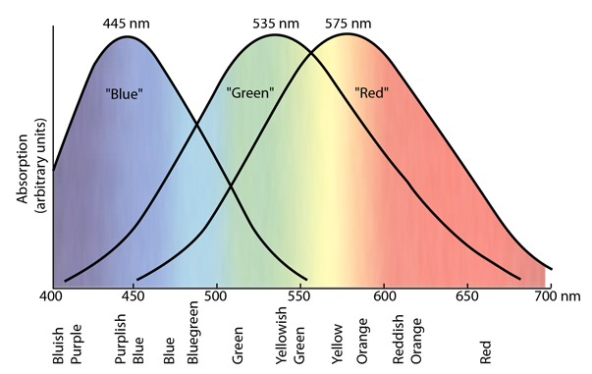
When I look at the response curves for the RGB colors I see that the reds are more sensitive to longer wavelengths (around 575nm). The greens are sensitive to medium sized wavelengths (around 535nm). The blues are sensitive to shorter wavelengths (around 445nm), meaning they have the highest sensitivity. The red
- Given the information above, explain why the Bayer pattern on camera sensors has two green sensors for every one blue or red sensor.
The human eye has a three types of cones; L, M, and S for long, medium, and short wavelengths, where L cones are most common, and M are the second most common (https://en.wikipedia.org/wiki/Cone_cell). However, humans are most sensitive to green light under normal lighting conditions, making it reasonable for the Bayer patter to have two green sensors for every one blue or red sensor.
(Hint: a good website is http://hyperphysics.phy-astr.gsu.edu/hbase/vision/rodcone.html)
3. Do some research on Bayer Patterns / Bayer Filter (the wikipedia site is pretty good).
- What are some issues that might arise because of the interpolation of colors to get RGB values at each pixel?
Moire: repetitive patters, color artifacts, or pixels arranged in a maze-like pattern
Color fringing: unnatural shifts in color along the edges of an image
Color inaccuracy: inaccurately interpolated colors
- What is the benefit of saving RAW images and doing interpolation off the camera?
RAW images contain unprocessed data directly from the camera sensor. Since processing steps are done after the image is off the camera, the user has more control over how the final image looks.
- Why might you want to use Cyan-Magenta-Yellow (CMY) instead of RGB filters? How would you get RGB values?
CMY have a higher quantum efficiency, meaning they produce more accurate colors. They allow more light to pass through, which results in better sensitivity. To convert CMY values to RGB, you do the following: C = 255 minus R (or 1 - r), M = 255 minus G (or 1 - g), and Y = 255 - B (or 1 minus b). http://www.huevaluechroma.com/092.php
4. Color Spaces
- When would it be important to use the CIE-Luv color space?
It would be important to use the CIE-Luv color space where consistent color differences are important. It’s designed to attempt perceptual uniformity, which is where the difference in colors is “less than the just-noticeable-difference threshold”. So this would be very important in the printing or camera industry, somewhere where high color quality is necessary.
https://en.wikipedia.org/wiki/CIELUV
- For the YUV color space, the U channel is often called Blue - Yellow, and the V channel is often called Red - Cyan. Given the RGB to YUV conversion matrix, explain why U and V have those labels (you can find the matrix on Wikipedia or in my lecture notes).
https://www.pcmag.com/encyclopedia/term/yuvrgb-conversion-formulas
In the YUV color space, Y represents luminance, U represents the blue difference with the luminance, and V represents the red difference with the luminance. U is called blue-yellow because it subtracts yellow (a mix of red and green) from blue. Same goes for red-cyan. The V channel subtracts cyan (a mix of green and blue) from red.
- Is there any connection between the UV definitions and the human visual system?
In the YUV color space, Y represents luminance, U represents the blue difference with the luminance, and V represents the red difference with the luminance. The luminance and chrominance are separated and allows for the color info to be encoded in a way similar to human vision. The human visual system is less sensitive to color than to luminance.

